Social Media Recommendation Application Based on Reviews
The “Social Media Recommendation Application” is an advanced tool designed to analyze and filter reviews of social media applications in the DE’Store. Its purpose is to offer tailored recommendations based on user preferences and sentiments. As a programmer, your objective is to develop this application with precision, ensuring it accurately assesses reviews and suggests social media applications that align with users’ preferences and emotions.
- First, the application will check whether there is “model.pickle” file in the application directory or not.
- If the file exists, then the application will read and load the data training from the file.
- If the file doesn’t exist, then the application will train the review data with Naïve Bayes Classifier from NLTK data twitter sample provided in “dataset.csv”. The data training will be following these rules:
- Preprocess the dataset by tokenizing the words, remove stop words, remove symbols and number, stemming, and lemmatizing the words.
- Compare the review words with the words in the list of dictionaries.
- If the review is in the good category, then set the review category to positive.
- If the review is in the neutral category, then set the review category to neutral.
- If the review is in the not good category, then set the review category to negative.
- Train the model using Naïve Bayes.
- Save training model to pickle file with format name “model.pickle”.
- The application menu will show user reviews and their respective classifications based on the provided categories, consisting of four menus. Validate in the menu, that user can only choose number in the range of menu provided (1 – 4).
      - Write Your Review
      - View Social Media Recommendation
      - View Named Entity Recognition
      - Exit
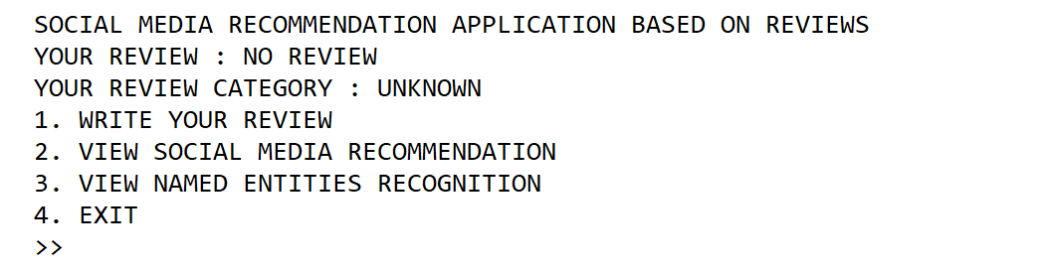
Figure 1. Main Menu (No Review)
- If user choose menu 1 (“Write Your Review”), then the application will:
- If there are saved reviews, ask the user whether they want to rewrite their reviews or not. Validate that the input must be ‘Y’ or ‘N’.
- If the reviews are not available yet or the user agrees to rewrite existing reviews. Ask the user to input review. Validate that the input must at least contains of 15 words.
- Afterward, the application will save the review and display the review category in the main menu.
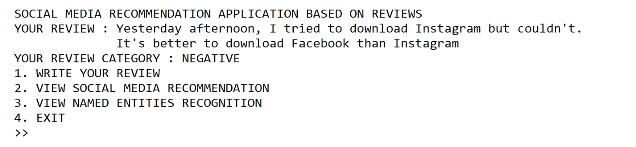
Figure 2. Main Menu (Review Exists)
- If user choose menu 2 (“View Social Media Recommendation”), then the application will:
- Check whether there is a review or not.
- If there is no review exists, then show a message to notify the user and redirect user back to main menu.
- The application should support one text representation or word embedding techniques for feature extraction, allowing the examiner to choose from TF-IDF, Word2Vec, or language models such as unigram, bigram, or trigram. The selected technique should be applied during the recommendation process to calculate cosine similarities between user queries and document text.
- Calculate the cosine similarities of the user queries with the documents that have been embedded using any text representation or word embedding techniques.
- Display the top 3 social media from the cosine similarity results as social media recommendations.
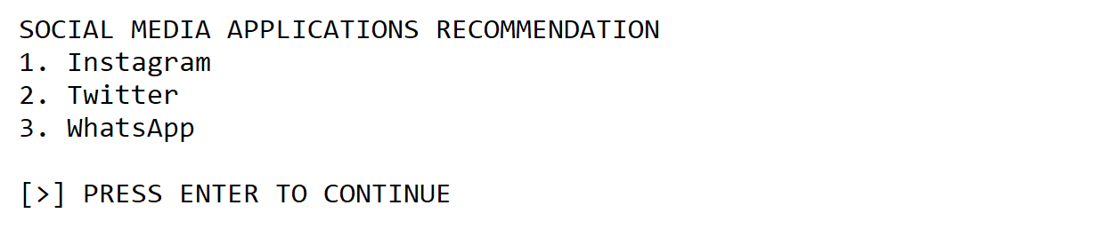
Figure 3. The Top 3 Social Media Recommendation Result
- If user choose menu 3 (“View Named Entity Recognition”), then the application will:
- If there is no review exists, then show a message to notify the user and redirect user back to main menu.
- Display entity tags such as time and cardinal, along with the corresponding entity items present in the document.
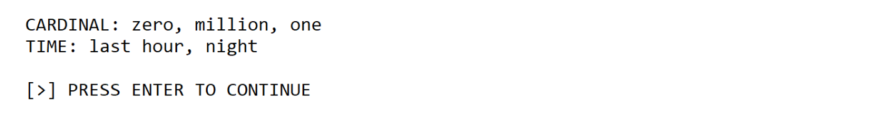
Figure 4. Named Entity Recognition Result
- If user choose menu 4 (“Exit”), then terminate the application.

